
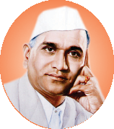






Curricular Planning and Implementation
(1.1.1: The Institution ensures effective curriculum planning and delivery through a well-planned and documented process including Academic calendar and conduct of continuous internal Assessment)

Sr. No. | Particulars | Link
Curricular Planning
 | Organogram: Academic and Administrative Structure, Academic flow chart | View
 | Guidelines for the conduct of academics at the College | View
 | Academic Committees of staff (Sample Copy) | View
 | SPPU (Affiliated University) Academic Calendars | View
 | College Academic Calendars and Working days (Sample Copy) | View
 | SPPU Examination Schedule | View
 | Distribution of Workload amongst the staff members (Sample Copy) | View
 | Academic Time Tables (Sample Copies) | View
 | Teaching Plans (Sample Copies) | View
 | E-content (Study Material) (Sample Copies) | View
 | Google classroom (Sample Copy) | View

