
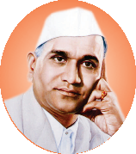
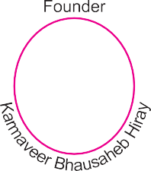





Curricular Planning and Implementation
(1.1.3 Teachers of the Institution participate in curriculum development and assessment)

Sr. No. | Particulars | Link
1.1.3 Teachers of the Institution participate in curriculum development and assessment
 | Faculty Participation in the paper setting (Sample appointments) | View
 | Skill up-gradation of faculty members (Sample Certificates) | View
 | Faculty Participation in assessment (Sample appointments) | View

