
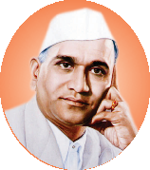






1.2 Academic Flexibility

(1.2.1 Number of Programmes in which CBCS/ Elective course system implemented)

Sr. No. | Particulars | Link
1.2.1 Number of Programmes in which CBCS/ Elective course system implemented
1 | Number of Programmes in which CBCS/ Elective course system implemented | View

