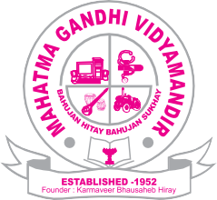
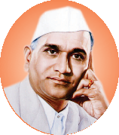
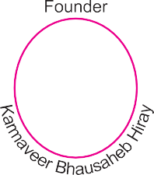

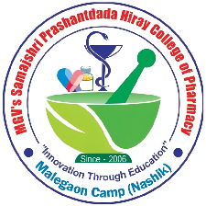

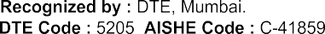

  - Curriculum Enrichment

(1.3.2 Number of students undertaking project work/field work/internship)

Sr. No. | Project list | Link
1.3.2 Number of students undertaking project work/field work/internship
01 | Projects of Final Year B. Pharm | View
02 | Industrial Training/Internship Data | View
03 | Environmental Sciences Projects of First year B. Pharm | View

